Neural Network Assignment -3
Name = Hema Rajput
Roll no = 24UADS1062
3.WAP to implement a three-layer neural network using Tensor flow library (only, no keras) to classify MNIST handwritten digits dataset. Demonstrate the implementation of feed-forward and back-propagation approaches.

# %matplotlib inline #

import tensorflow as tf
import numpy as np
import matplotlib.pyplot as plt
import random

# ==============================
# 1. LOAD MNIST DATASET
# ==============================

(x_train, y_train), (x_test, y_test) = tf.keras.datasets.mnist.load_data()

# ==============================
# 2. PREPROCESS DATA
# ==============================

x_train = x_train.reshape(-1, 784).astype(np.float32) / 255.0
x_test = x_test.reshape(-1, 784).astype(np.float32) / 255.0

# FIX: Convert labels to int32
y_train = y_train.astype(np.int32)
y_test = y_test.astype(np.int32)

# ==============================
# 3. DEFINE PARAMETERS
# ==============================

input_size = 784
hidden1 = 256
hidden2 = 128
output_size = 10

learning_rate = 0.001
epochs = 5
batch_size = 256

# ==============================
# 4. WEIGHT INITIALIZATION
# ==============================

W1 = tf.Variable(tf.random.normal([input_size, hidden1], stddev=0.1))
b1 = tf.Variable(tf.zeros([hidden1]))

W2 = tf.Variable(tf.random.normal([hidden1, hidden2], stddev=0.1))
b2 = tf.Variable(tf.zeros([hidden2]))

W3 = tf.Variable(tf.random.normal([hidden2, output_size], stddev=0.1))
b3 = tf.Variable(tf.zeros([output_size]))

# ==============================
# 5. FEED FORWARD FUNCTION
# ==============================

def forward(X):
X = tf.cast(X, tf.float32)

Z1 = tf.matmul(X, W1) + b1
A1 = tf.nn.relu(Z1)

Z2 = tf.matmul(A1, W2) + b2
A2 = tf.nn.relu(Z2)

Z3 = tf.matmul(A2, W3) + b3
return Z3 # logits (NO softmax here)

# ==============================
# 6. TRAINING (BACKPROPAGATION)
# ==============================

optimizer = tf.optimizers.Adam(learning_rate)

loss_history = []
acc_history = []

dataset = tf.data.Dataset.from_tensor_slices((x_train, y_train))
dataset = dataset.shuffle(60000).batch(batch_size)

for epoch in range(epochs):

epoch_loss = 0
batch_count = 0

for x_batch, y_batch in dataset:

with tf.GradientTape() as tape:
logits = forward(x_batch)

loss = tf.reduce_mean(
tf.nn.sparse_softmax_cross_entropy_with_logits(
labels=y_batch,
logits=logits
)
)

gradients = tape.gradient(loss, [W1, b1, W2, b2, W3, b3])
optimizer.apply_gradients(zip(gradients, [W1, b1, W2, b2, W3, b3]))

epoch_loss += loss.numpy()
batch_count += 1

epoch_loss /= batch_count
loss_history.append(epoch_loss)

# TEST ACCURACY
test_logits = forward(x_test)
predictions = tf.argmax(test_logits, axis=1)

accuracy = tf.reduce_mean(
tf.cast(predictions == y_test, tf.float32)
)

acc_history.append(accuracy.numpy())

print(f"Epoch {epoch+1}, Loss: {epoch_loss:.4f}, Accuracy: {accuracy.numpy():.4f}")

# ==============================
# 7. PLOT LOSS & ACCURACY
# ==============================

plt.figure(figsize=(12,5))

plt.subplot(1,2,1)
plt.plot(loss_history)
plt.title("Training Loss")
plt.xlabel("Epoch")
plt.ylabel("Loss")

plt.subplot(1,2,2)
plt.plot(acc_history)
plt.title("Test Accuracy")
plt.xlabel("Epoch")
plt.ylabel("Accuracy")

plt.show()

# ==============================
# 8. VISUALIZE PREDICTIONS
# ==============================

indices = random.sample(range(len(x_test)), 10)

plt.figure(figsize=(12,4))

for i, idx in enumerate(indices):

img = x_test[idx].reshape(28,28)
pred = predictions[idx].numpy()

plt.subplot(2,5,i+1)
plt.imshow(img, cmap='gray')
plt.title(f"Pred: {pred}")
plt.axis('off')

plt.show()

print("Final Test Accuracy:", accuracy.numpy())

Output

Epoch 1, Loss: 0.3556, Accuracy: 0.9544

Epoch 2, Loss: 0.1275, Accuracy: 0.9652

Epoch 3, Loss: 0.0843, Accuracy: 0.9719

Epoch 4, Loss: 0.0588, Accuracy: 0.9740

Epoch 5, Loss: 0.0433, Accuracy: 0.9774

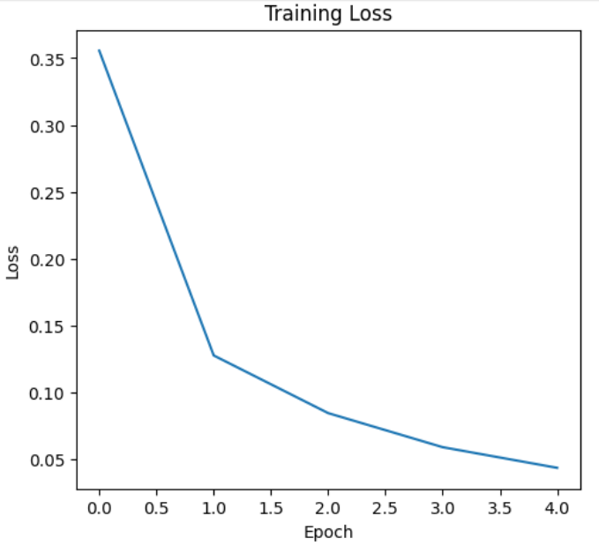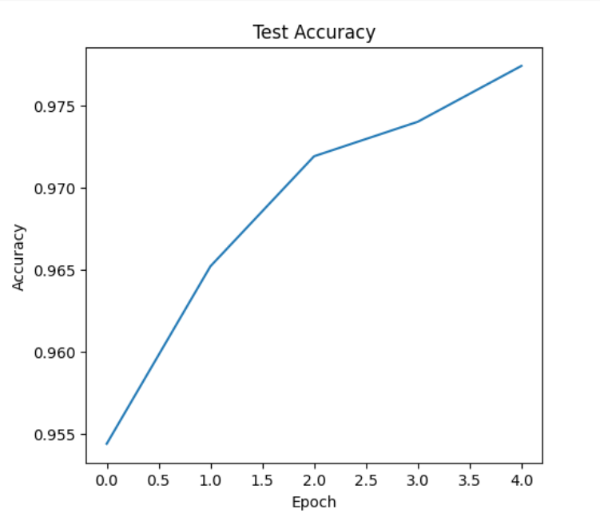

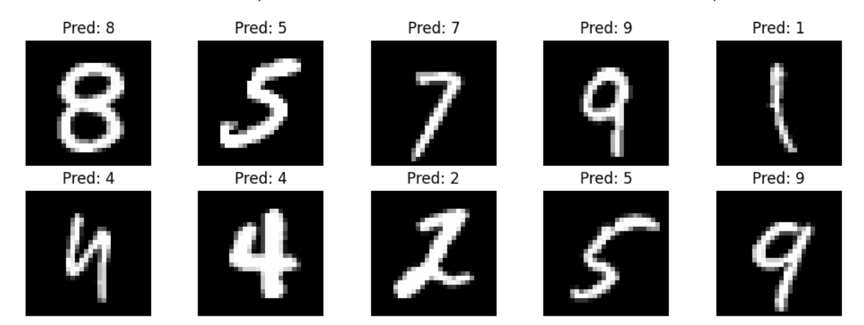

Final Test Accuracy: 0.9774

## Comment ##

What I Learned from This Code

From this project I learned how a neural network works I understood how to download the MNIST dataset and prepare the data before giving it to the model I learned how to create a three-layer neural network using TensorFlow including input layer hidden layers and output layer
Problems I Faced
At the beginning, I faced problems installing TensorFlow and setting it up in Jupyter Notebook because of Python version issues. I also got confused about matrix multiplication shapes and how layers connect with each other. Sometimes I was not sure whether my loss calculation was correct.

